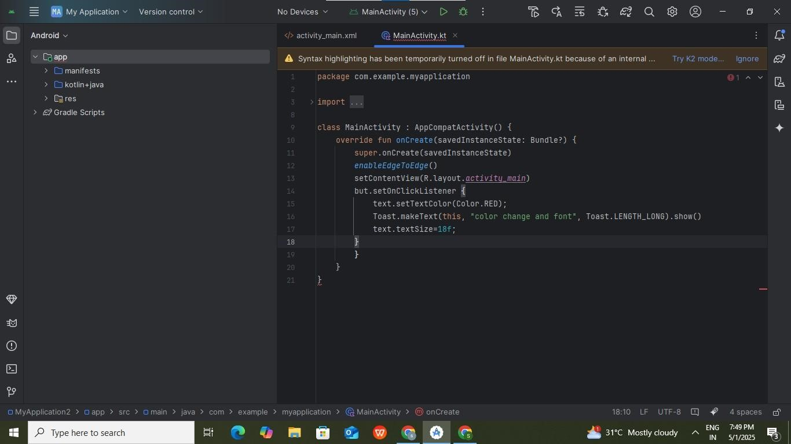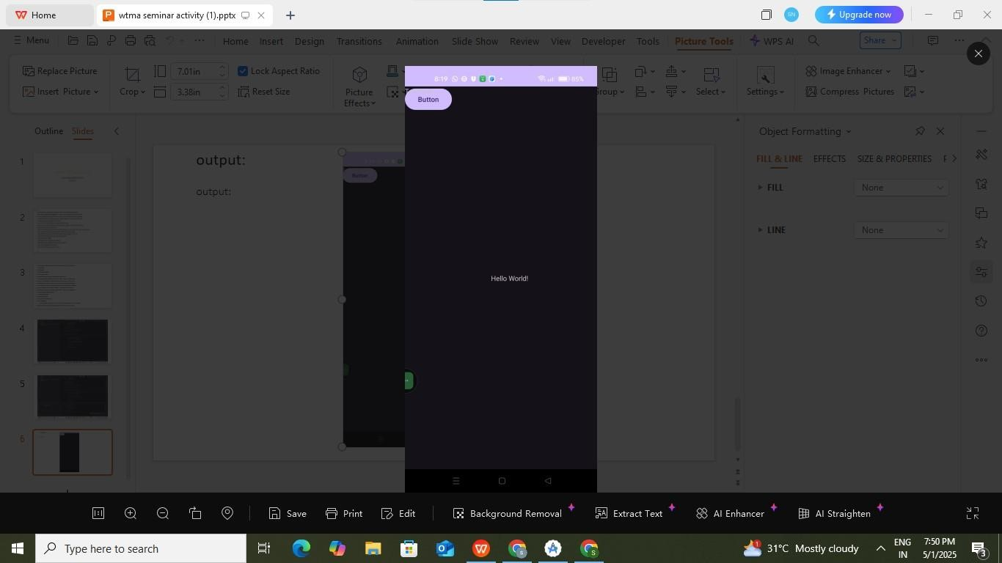

AIM:

To develop an
droid applicati
on
to change the col
o
r and
font of the text.

PROGRAM:

OUTPUT
:

RESULT :

Thus the experiment
has been successfully implemented and verified

Exp No:

10

Date:

26
.04
.25

DEVELOP AND
ROID APPLICATION
TO CHANGE THE COLOR AN
D
FONT OF THE TEXT

